Table 1. Patient Demographics and Lesion Characteristics
 | Overall (n=40) | OCD (n=14) | OCL (n=26)
Sex (%)
Female | 42.5 | 50.0 | 38.5
Male | 57.5 | 50.0 | 61.5
Age (years) | 14.9 (10.1-21.6) | 15.1 (12.5-17.7) | 14.6 (10.1-21.6)
Lesion Characteristics
Mean Size (mm²) | 298.8 (96-780) | 362 (130-780) | 235.6 (96-460)
Mean Major length (mm) | 19.05 (11-30) | 20.4 (13-30) | 17.7 (11-27)
Mean Depth (mm) | n/a | 9.5 (5.3-14) | n/a
Bone progeny (%) | n/a | 71.4 | n/a
Osteochondral fracture (%) | n/a | n/a | 80.8
Chondral fracture (%) | n/a | n/a | 19.2
Lesion Location (n)
Condylar | 20 | 8 | 12
Trochlear | 3 | 3 | 0
Patellar | 17 | 3 | 14

Table 2. OCD Patient Reported Outcomes
mean ± SD | Baseline | 6 Month | 1 Year | p-value
KOOS Daily Living | 74.2 ± 18.6 | 91.8 ± 10.7 | 92.5 ± 8.9 | <0.01
KOOS Pain | 66.5± 19.5 | 88.6 ± 14.5 | 91 ± 10.6 | <0.01
KOOS Quality of Life | 37.5 ± 14.7 | 55.8 ± 31.5 | 76.6 ± 23.8 | <0.01
KOOS Symptoms | 59.1 ± 20.3 | 73.8 ± 27.8 | 87.5 ± 13.5 | 0.02

Figure 1:
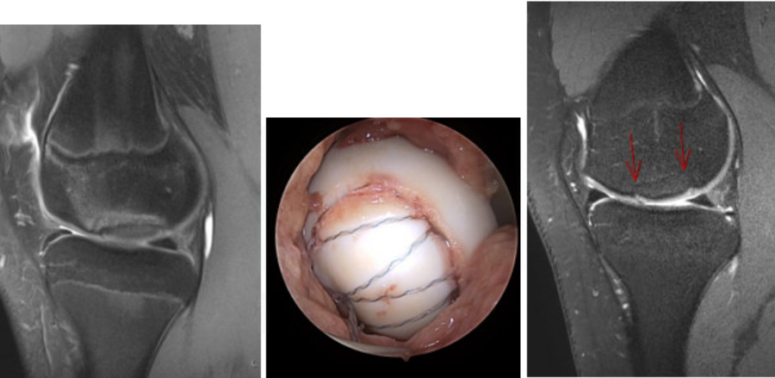
Demonstration of a typical adolescent osteochondritis dissecans lesion (OCD) treated with suture-bridge fixation. A. Pre-operative MRI of OCD with instability in situ. B. Immediate operative image of OCD with suture bridge construct utilizing bioabsorbable knotless anchors and braided polyester tape suture. C. Post-operative MRI (12 months post-op) demonstrating full union of the lesion with bridging cancellous bone and appropriate cartilage signal.

Figure 2:
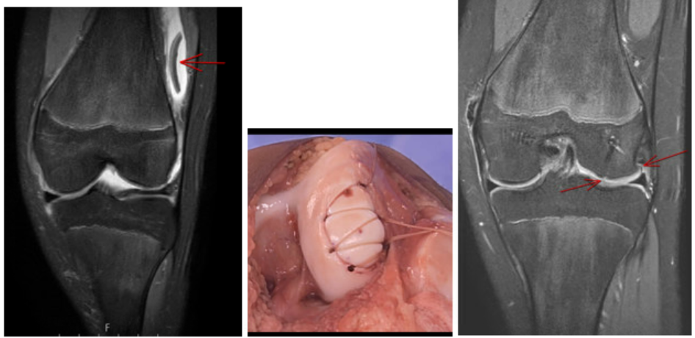
Demonstration of a typical adolescent osteochondral fracture lesion (OCL) treated with suture-bridge fixation. A. Pre-operative MRI of OCL in lateral gutter with minimal subchondral bone present. B. Immediate operative image of OCL with suture bridge construct utilizing bioabsorbable knotless anchors and #0Vicryl absorbable suture. C. Post-operative MRI (6 months post-op) demonstrating full union of the lesion with no fluid or fibrous signal with full incorporation and appropriate cartilage signal.

