Figure 2. Lateral trunk tilt comparisons for: a) high school (HS) and professional (PRO) pitchers; b) excessively ipsilateral, neutral, and contralateral high school pitchers; and c) excessively ipsilateral, neutral, and contralateral professional pitchers.
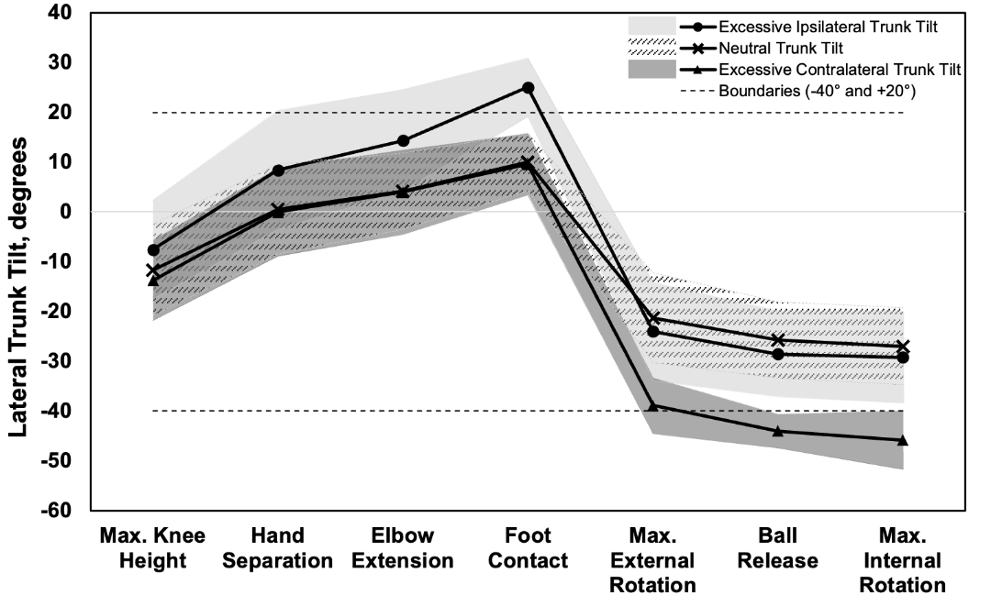
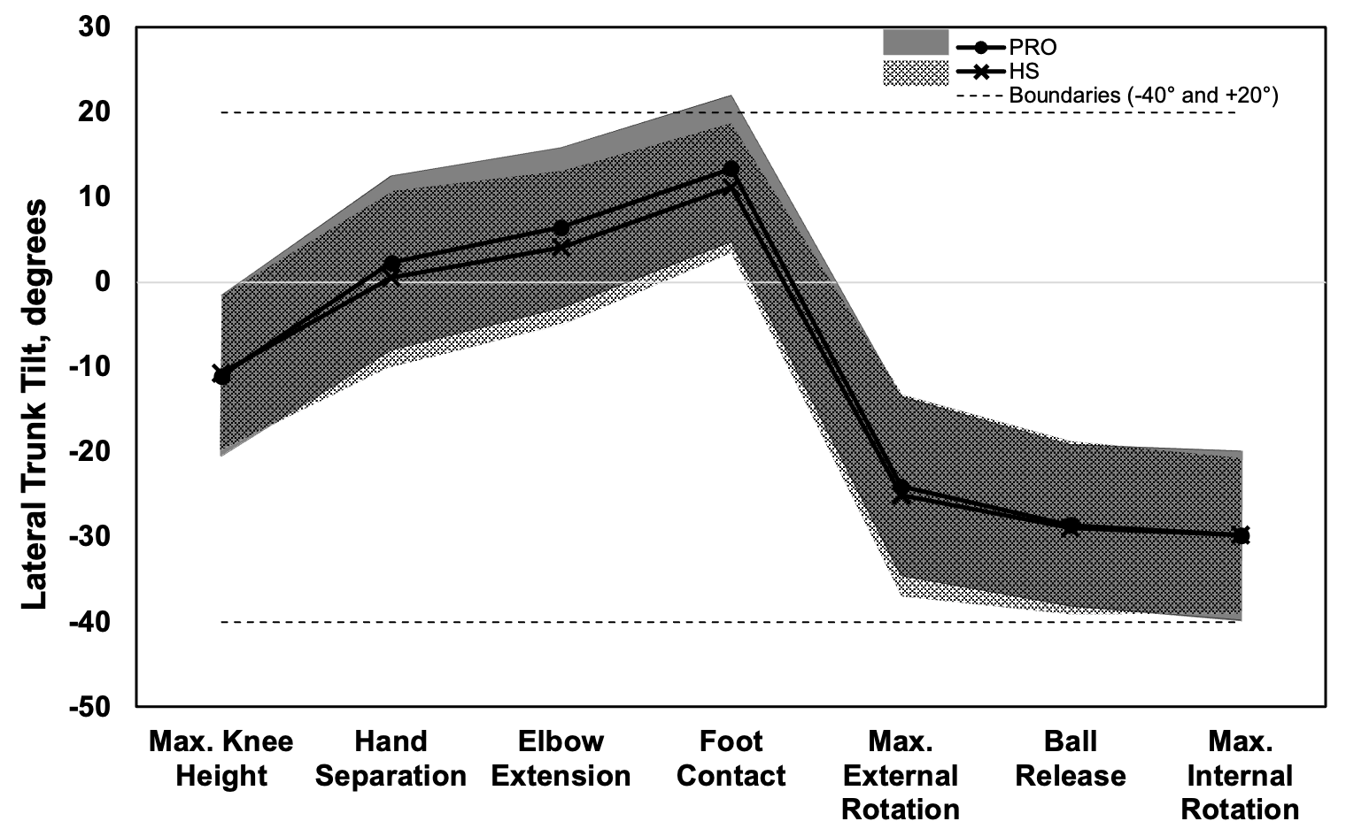
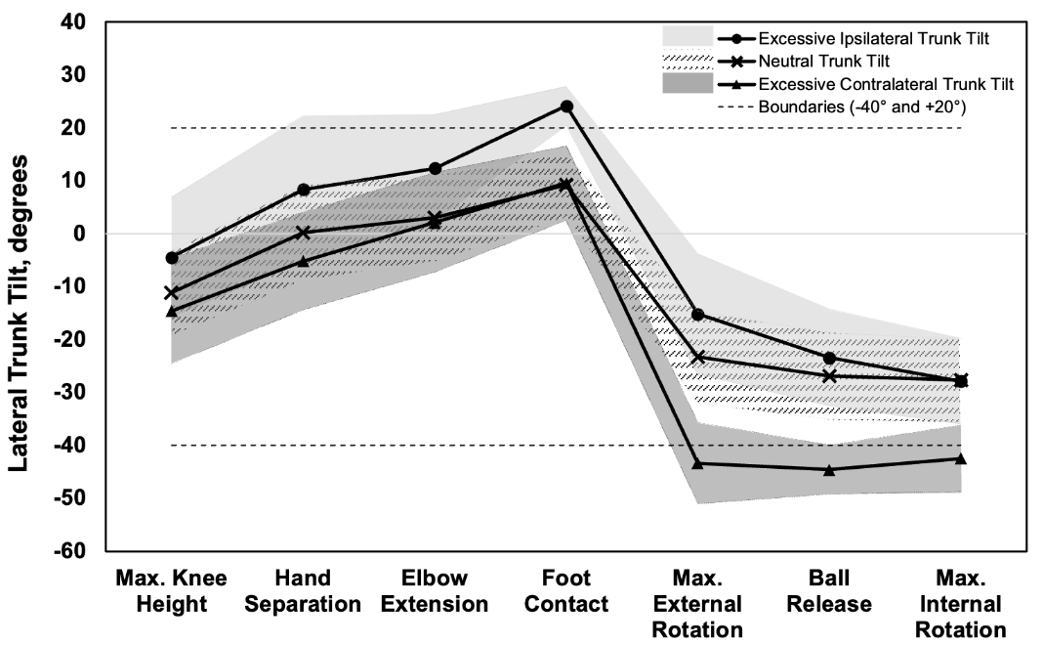
B
C
A

