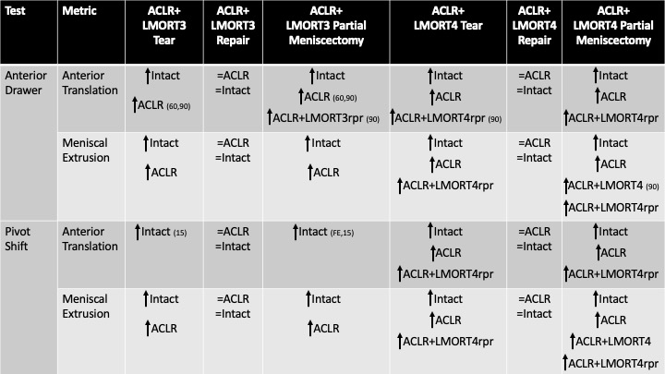
Key - ↑- significantly greater than; = - not significantly different; ( ) = specific knee flexion angle(s) for differences.
Table 1: Summary of Major Kinematic Effects for LMORT Lesions and Repairs

